20th September 2017

**Competition Heats up after FIA ETCC in Zolder**

The rounds 9/10 of the FIA European Touring Car Cup took place last weekend at Zolder, Belgium.

Following the spectacular racing in Belgian territory, the conclusion of the season is gearing up for a dramatic finale with four drivers heading to the final two races in Czech Republic next month separated by just seven points. Race victories for Rikli Motorsport’s Christjohannes Schreiber and Stefanovski Racing Team’s Igor Stefanovski at the former home of the Belgian Grand Prix ensures the closing two events at Most (Czech Republic) from October 6-8, will be unmissable as the title battle plays out.

Points leader Petr Fulín could only salvage a solitary third place in his Křenek Motorsport SEAT, which leaves him just six points in front – with Schreiber on 57 points, Stefanovski and Zengő Motorsport’s Norbert Nagy both tied on 56 points in third.

After the racing Christjohannes Schreiber (Race 1 winner and currently in second overall) stated “It was an amazing start in Race 1 and I knew we didn't have the pace as the fast cars this weekend. I tried to manage my start as well as possible and I think it was ok. My team-mate Peter did an amazing work there as well, he fought up the order and had a good fight with Norbi. Like this I was able to pull away and tried to manage my car and brakes as well as possible. In Race 2 my car was sideways a lot and I could feel that because my geometry was completely damaged. I think an Audi hit me on the entrance of the last chicane and there's a hole in my door and the geometry is completely off. I tried to limit the damage from that point and that's all I could do."

The Japanese premium tyre manufacturer YOKOHAMA, which is currently celebrating its 100th Anniversary is the Official Tyre supplier of the FIA ETCC.

Current Standings FIA ETCC:

1. Petr Fulin 63
2. Christjohannes Schreiber 57
3. Norbert Nagy 56
4. Igor Stefanovski 55

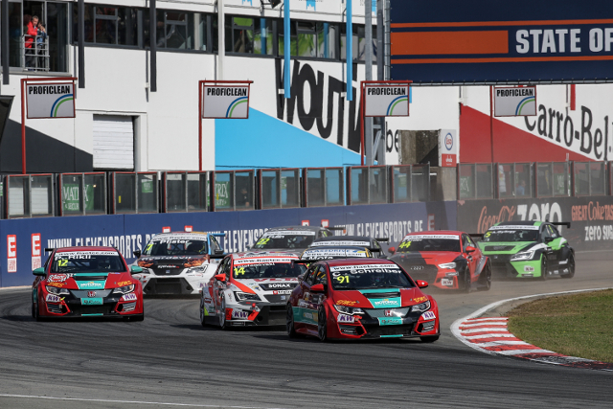

*FIA ETCC Race of Zolder_Race 1 Action*

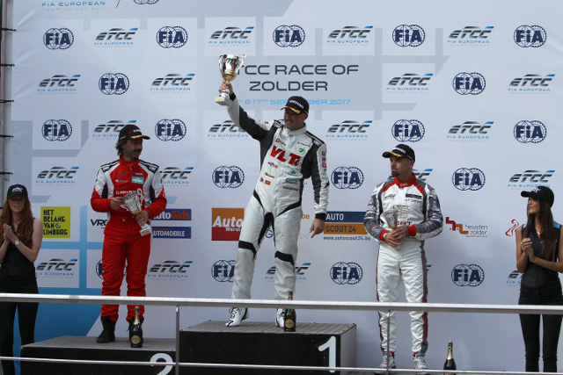

*FIA ETCC Race of Zolder_Race 2 Podium*